Coffee Maker Project



CEP Report

By

|  |  |
| --- | --- |
| NAME | Registration Number |
| Syed Zulfiqar Ali | CIIT/FA20-EEE-059 |
| Syed Hasnat Ali | CIIT/FA20-EEE-058 |

For the course

Microprocessor System and Interfacing

Semester Fall 2022

Supervised by:

## Sir Usman Khalid

Department of Electrical & Computer Engineering

COMSATS University Islamabad

## DECLARATION

We Syed Zulfiqar Ali (CIIT/FA20-EEE-059), and Syed Hasnat Ali (CIIT/FA20-EEE- 058) hereby declare that we have produced the work presented in this report, during the scheduled period of study. We also declare that we have not taken any material from any source except referred to wherever due. If a violation of rules has occurred in this report, we shall be liable to punishable action.

Date: _09-01-2023

Syed Zulfiqar Ali (CIIT/FA20-EEE-059)

Syed Hasnat Ali (CIIT/FA20-EEE-058)

## ABSTRACT

A coffee maker is disclosed, having at least one coffee bean container adapted to receive whole coffee beans and a brewing module including a brewing chamber for brewing a coffee beverage by means of hot brewing water. The aim of this project is to cater to the specific requirement of the consumer especially of small scale sector with the intention of providing the consumer with the option of selecting the types of coffee he/she wants. This coffee machine provides two flavors of coffee to our customers according to their taste.

## TABLE OF CONTENTS

ABSTRAT 03

DECLARATION 02

1. Introduction 06
2. Literature Survey 07
3. Proposed Methodology 07
4. Simulation Results 09

LIST OF FIGURES

Fig: 1.1 Title of the Picture Not Defined

Fig: 3.1 Single Block Diagram 8

Fig: 3.2 Circuit Diagram 8

Fig: 3.3 Flow chart Not Defined

Fig: 4.1 simulation results1 09

Fig: 4.1 simulation results2 10

**LIST OF ABBREVIATIONS**

PIC18F452 Peripheral Interface Controller

LCD Liquid Crystal Display

RES Resistor

LED Light Emitting Diode

## Introduction

Beverages like tea and coffee have become a part of a daily routine of people around the world. A coffee maker is described as a plug in appliance that pushes hot water through coffee beans to create coffee. A coffee maker is composed of a heating plate on the bottom, a glass pitcher to catch the coffee in, a water reserve tank, a cup of to hold coffee grounds, and a tube to tie this all together. The water from the reserve tank flows through the heating plate, boils, and then is sent up the tube to wash down through the beans. After it has seeped through the beans, it goes into the glass pitcher which holds it until the user is ready to use it.

## Objectives

The objective of the project is to design and develop a mini tea and coffee making machine, which dispenses the beverage of required quality in less time. The machine uses readily available tea and coffee premix powder to prepare the beverage. The machine offers options like:

* Cappuccino
* Espresso
* Mild Tea/Coffee
* Sugar free Tea/Coffee

## Features and Cost Estimate of our Project

* + - Reduces Labour cost
    - Assurance of Hygiene
    - Maximum efficiency
    - High safety appliance

The total estimated cost of the project is Five Hundred Thousand.

## Literature Survey

During the course of the project, two distinct type of tea and coffee machines were observed: • Household Tea and Coffee Machine • Tea and Coffee Vending Machine. The working of these appliances is quite simple. The appliance consists of a container made of plastic in which tea or coffee premix powder is placed according to the requirement of the user. The appliance consists of a reservoir for storing water, this reservoir is connected to the heater. The quantity is of water is measured according to the requirement by the user and when the user switches on the machine the water gets heated and pours into the container thereby providing the required beverage. Tea and Coffee Vending Machines are quite complex and generally used in hotels or cafeterias or large offices. These machines generally consist of an Electronic System which controls all the operations, Heating System to ensure that the water is always heated and remains at the required temperature, Mechanical system for controlling the amount of premix powder, this is generally done by using screw extrusion process. These machines provide an interface from which the user has to select the type of beverage he/she wants. Once the input from the user has been registered, the screw present in the powder container rotates. Corresponding to the amount of revolutions of screw the powder falls into a secondary cup where a stream of hot water mixes with the powder and the beverage is produced which then flows in to the main cup. The amount of water flowing is controlled by valves which are operated using timing circuits.

## Proposed Methodology

* 1. **Mathematical Model**

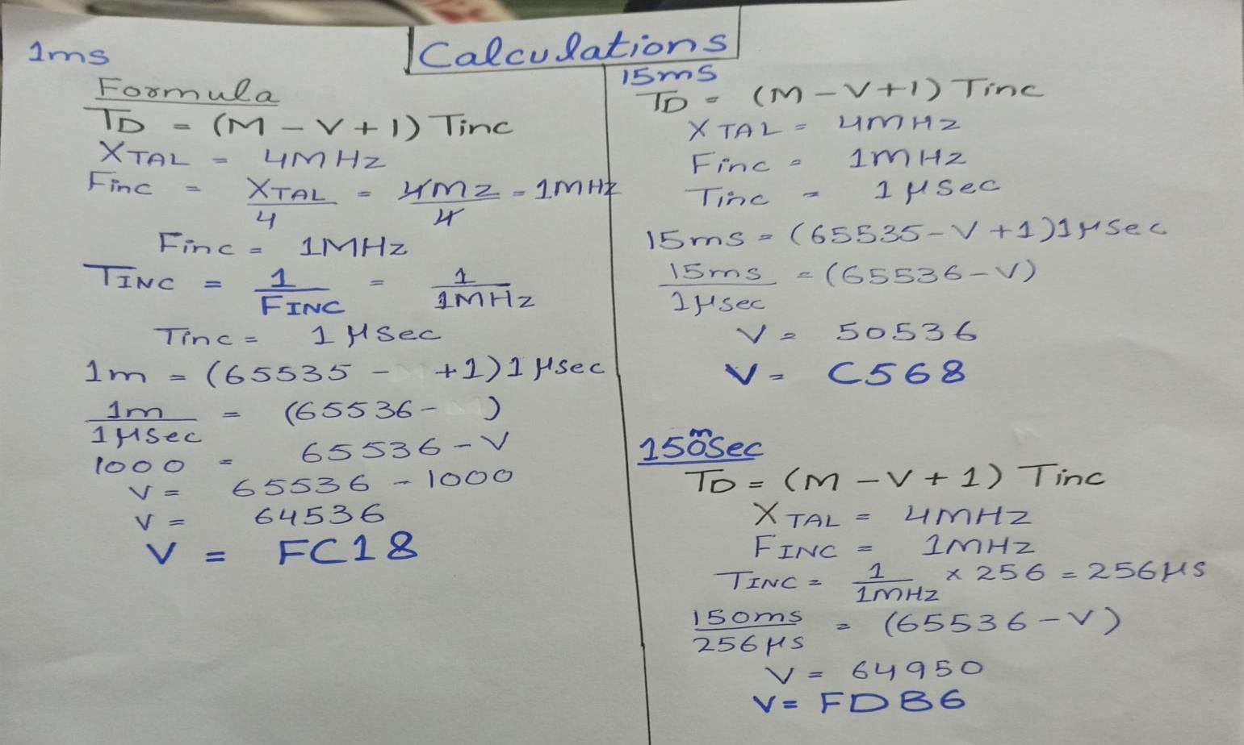

## Flow Chart

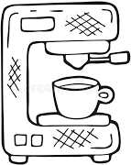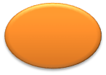

**Welcome to Syed Coffee**

**Maker**

**Select Your Choice**

**Cappuccino**

**Espresso**

**Ready to**

**Serve**

**Fig: 1 (Flow Chart)**

**Process in Progress**

* 1. **Hardware model**

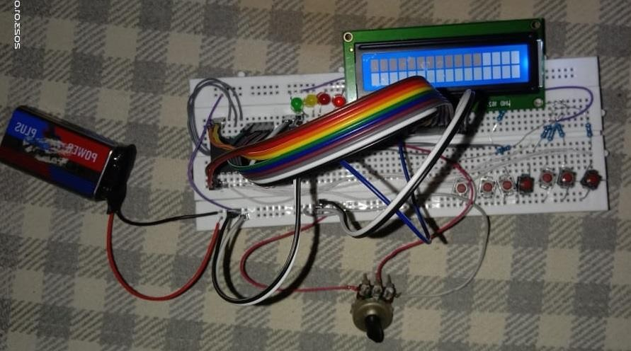

**Fig: (2) Hardware Model**

8

## Circuit diagram

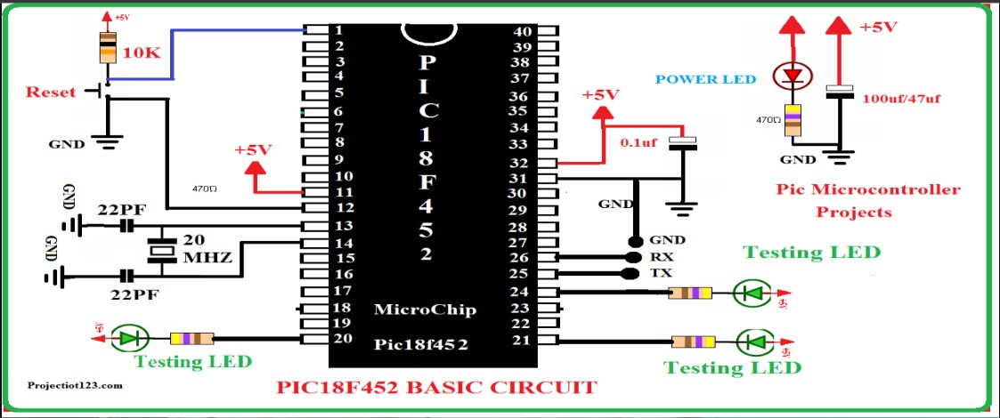

**Fig: (3) Circuit Diagram**

## Block Diagram

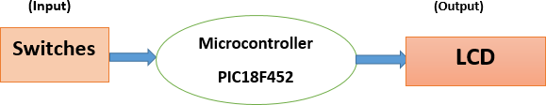

9

## Components Required

* 9V Battery
* RES (10K)
* LEDS
* PIC18F452 Microcontroller
* Jumper Wires
* LCD (16 x2)
* Oscillator (4MHZ)
* Switches
* Potentiometer(10k)

## Simulation Results

* 1. **Software simulation results**

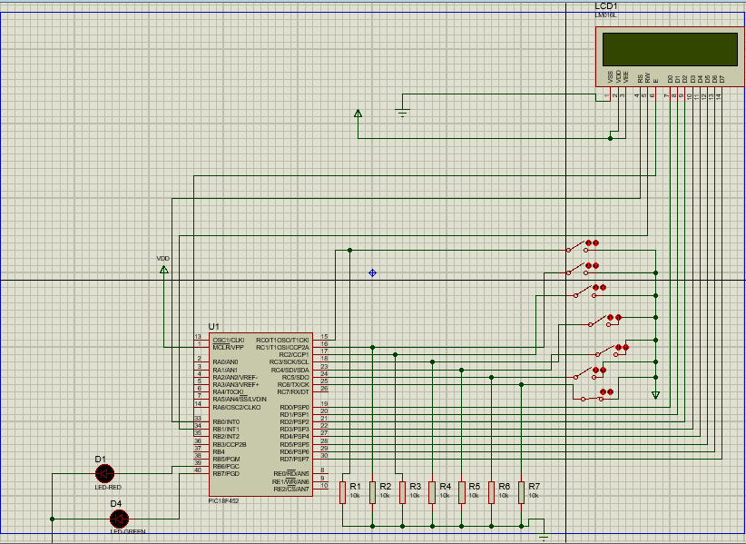

**Fig: (4) simulation results1**

10

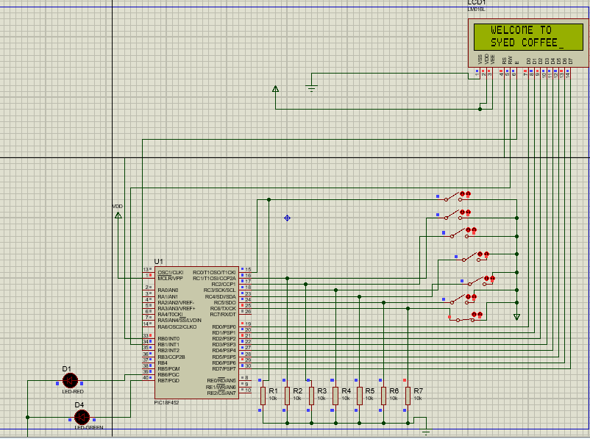

**Fig: (5) simulation results2**

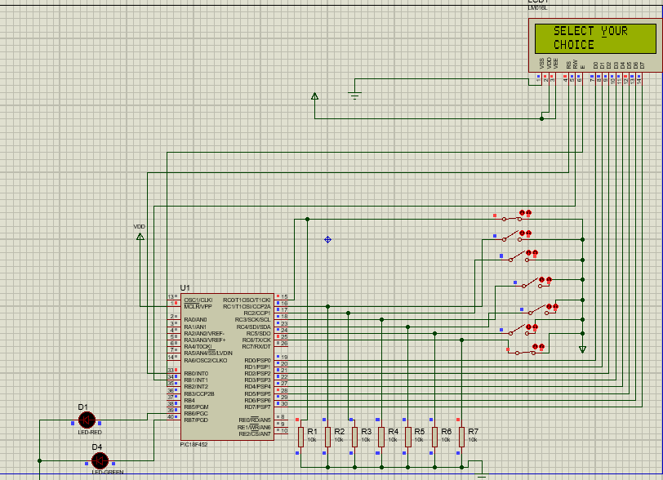

**Fig: (6) Simulation result3**

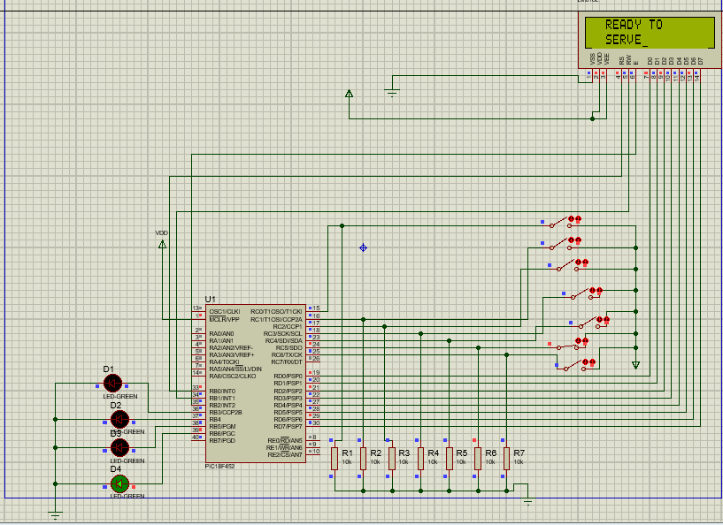

**Fig: (7) Simulation result4**

## Simulation parameters

**9V Battery**

The 9V (nine volt) battery is a rectangular dry cell classified by its 48.5mm x 26.5mm x 17.5mm dimensions and one-sided clasp terminals. They hold mid-range capacities upwards of 1,200mAh and were often used in radios, but today are used more for walkie-talkies, clocks, smoke detectors, and house alarms.

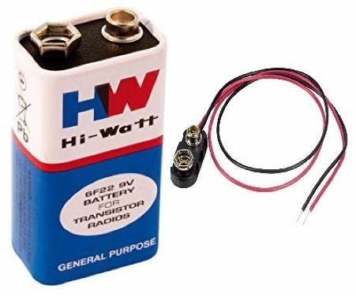

**Fig: 8 (Battery)**

## LCD

The term LCD stands for liquid crystal display. It is one kind of electronic display module used in an extensive range of applications like various circuits & devices like mobile phones, calculators, computers, TV sets, etc. These displays are mainly preferred for multi-segment light-emitting diodes and seven segments. The main benefits of using this module are inexpensive; simply programmable, animations, and there are no limitations for displaying custom characters, special and even animations, etc.

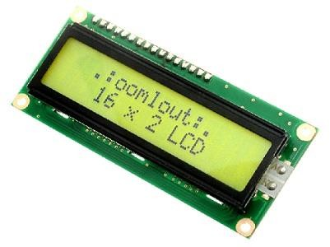

**Fig: 9 LCD(16x2)**

## PIC18F452 Microcontroller

A computer on a single chip is known as microcontroller. PIC18F452 is an 8-bit with 10 MIPS, CMPS, FLASH-based microcontroller that has 34 I/O pins out of 40 Pin packages. It is a powerful microcontroller with one 8-bit and three 16-bit timers, 8-Channels 10-bit Analog-digital converter, and I2C, SPI, USART peripheral. It is a Low power microcontroller unit that consumes about less than 0.2 uA standby current and 1.6mA normal current during 5V and 4 MHz operations. In has4kb Ram and 2MB ROM and consist of special function and general purpose register.

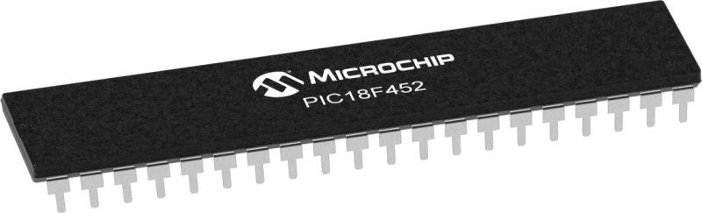

## Oscillator(4MZ)

**Fig: 10 (PIC18F452)**

An oscillator is a mechanical or electronic device that works on the principles of oscillation: a periodic fluctuation between two things based on changes in energy. Computers, clocks, watches, radios, and metal detectors are among the many devices that use oscillators. The oscillator speeds up the movement of data in transmissio n.

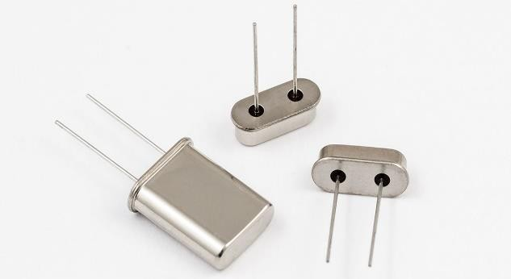

**Fig: 11 (Oscillator)**

## Switch

A push-button (also spelled pushbutton) or simply button is a simple switch mechanism to control some aspect of a machine or a process. Buttons are typically made out of hard material, usually plastic or metal.

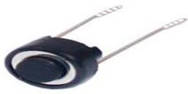

**Fig: 12 (Switch)**

## Discussion

This project can be enhanced with many features like different options can be added in coffee maker. We can add multiple flavours that can attract customers. Project can be launched in the proper way as a proper vending coffee machine as a business. A great homework is required to build the vending coffee machine in practical like better controllers can be selected with multiple options and with our programming logic we can add multiple features in this project.

# Conclusions

In this project, we have designed and developed a mini tea and coffee making machine that is software based which is capable of dispensing the required quality (taste) of beverage in less time. The powder separation mechanism used in this machine has certain advantages over the presently used screw extruder mechanism. For instance, it is less complex and is consistent in operation. The heating unit consumes less power, thereby reducing operating costs

# References

1. International Coffee Organization, “Coffee consumption table.pdf.” [Online]. Available: [http://www.ico.org/prices/new-consumptiontable.pdf,](http://www.ico.org/prices/new-consumptiontable.pdf) Apr-2017.
2. Tower, “Tower T13001.” [Online]. Available: https://[www.towerhousewares.co.uk/tea-coffee-makers-c8/10-](http://www.towerhousewares.co.uk/tea-coffee-makers-c8/10-) cup-coffeemaker-p45, Apr-2017.
3. Jura, “E6 - JURA United Kingdom.” [Online]. Available: https://uk.jura.com/en/homeproducts/automatic-coffee- machines/E6-EU15079#tabs, Apr-2017.
4. <http://www.burnsjournal.com/article/S0305-> 4179%2807% 2900255-0/abstract

## Appendix (Optional)

Teachers should assess CLO2, CLO3 and CLO4 based on the given rubrics (overall weightage 20%)

Recommended Percentage Breakdown

|  |  |
| --- | --- |
| **CLO** | **Percentage** |
| PLO2 (Problem Analysis) | 7% |
| PLO4 (Investigation) | 8% |
| PLO10 (Communication through  report) | 10% |
| PLO8 *(preferably Turnitin report*  *should be generated.)* | multiplicative |